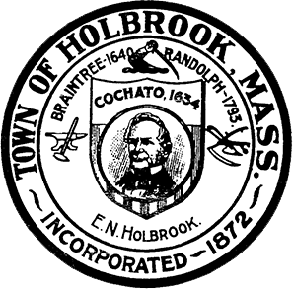
Town of Holbrook Board of Health
50 North Franklin Street Tel: 781-767-3030
Holbrook, Massachusetts 02343 Fax: 781-767-9562

Application for Permit to have Livestock
Fee : $50 Date:
Name of Establishment: Type & Numbers of Animals: Address: Days & Hours of Operation: Mailing Address (if different): Name of Applicant: Address of Applicant: Phone Number of Applicant: Name and Phone Number of Owner (if different from applicant):

Number of Square Feet in Lot & Zoning Description: Emergency Response Name & Phone Number:

Pursuant to MGL Chapter 62C, Section 49A, I certify under the pains and penalties of perjury that I, to the best of my knowledge and belief, have filed all state tax returns and paid all state taxes required under the law.
If you have any questions, please contact the Board of Health at 781-767-3030
**By signing below, I understand to the above, agree and to the best of my ability comply with the terms,

Rev. 10/19

