ELECTRONIC WASTE
DROP-OFF
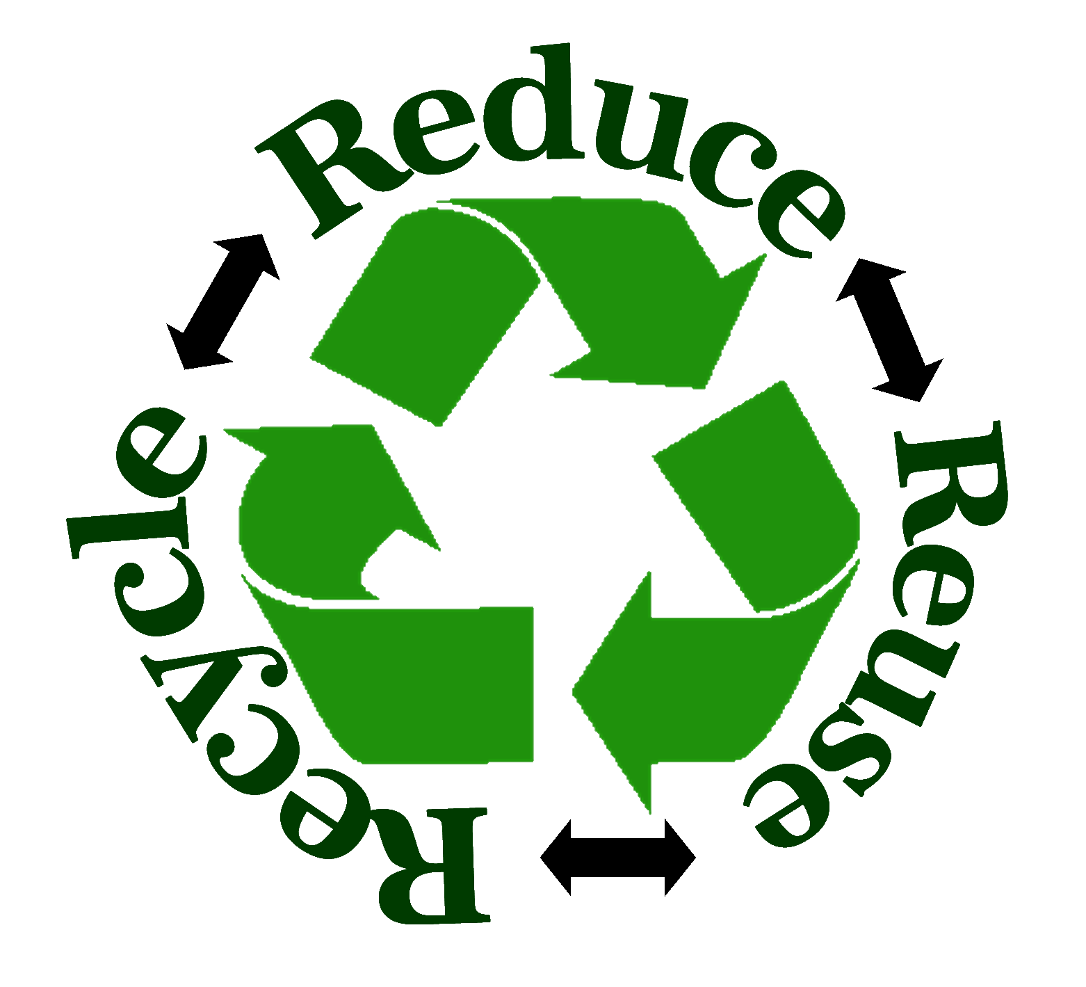Saturday, July 11, 2020
8:00 A.M. – 12:00 P.M.
Location: Rear of Town Hall
50 North Franklin Street, Holbrook MA 02343

Working and/or Non-working Equipment

ITEMS ACCEPTED FOR RECYCLING
A/C Units Laptops Routers
All Appliances Lawn Mowers Scanners
Ballasts Light Fixtures Scrap Metal
Batteries Medical Equipment Servers
Blenders Microwaves Snow Blowers
Cell Phones Modems Space Heaters
Chargers Monitors Speakers
Copiers Phones Strollers
CPU’s Pressure Washer Swing Set
Dehumidifier Printed Circuit Boards Switch Gear
Electrical Equipment Printers Toaster
Fax Machines Radios Towers
Fire Alarm Equipment Refrigerators Vacuums
Bicycles Filing Cabinets Wire
All fluids must be removed from lawn mowers and snow blowers that are being recycled.
Chargeable Items: Cash or Check made payable to Town of Holbrook
Televisions – 32” and above $30.00 Refrigerators, Washers, Dryers, Water Heater $20.00
Televisions < 32” $25.00 Air Conditioning Unit/Dehumidifier $10.00
Television Consoles $35.00 Space Heaters $ 5.00
Monitors flat panel FREE Lawn Mower/Snow Blower $20.00
CRT Monitors /tv <24” $15.00 Microwaves $ 5.00

