Holbrook

2021 Rain Barrel Program

Save Money, Collect Rain Water, Conserve Energy  
with the Great American Rain Barrel

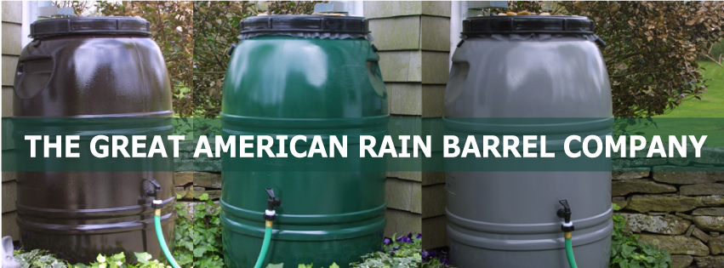

**To Order**

Contact the Holbrook Public Works Department

njordan@holbrookmassachusetts.us

(781) 767 -1800

**Pickup Info**

50 North Franklin St

Holbrook MA 02343

**While Supplies Last**

*Did you know* **that using a rain barrel to collect rainwater conserves energy, reduces storm water runoff and pollution, and may help you save money on your water bill?**

The Great American Rain Barrels are heavy duty and come with a choice of two ports to use with either a watering can or a garden hose. Each barrel holds 60 gallons and is available in 3 earth tone colors and unpainted.

**Residents are eligible to purchase rain barrels at the discounted rate of $65 for Forest Green, Earth Brown or Nantucket Gray (saving over 40% off the retail price).**

**Some Facts about the Great American Rain Barrel**

• Versatile design, sturdy construction • UV Protected, Food Grade BPA Free

• Each barrel holds 60 gallons • 100% recycled containers

• Manufactured in the USA • 20 years of satisfied customers