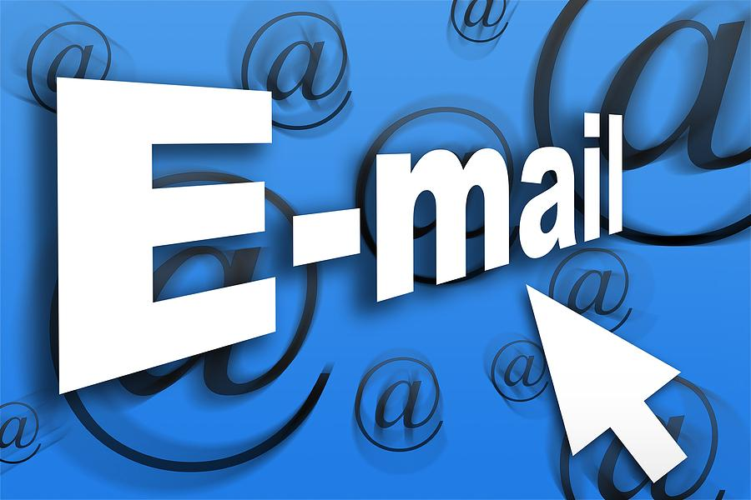

Water/Sewer/Trash Billing via Email

If you would like to receive your Water/Sewer/Trash bill via email instead of receiving a paper copy, please email njordan@holbrookmassachusetts.us

